Chip back potential is the level which bulk silicon is maintained by on-chip connection, or it is the level to which the chip back must be connected when specifically stated below. If no potential is given the chip back should be isolated.

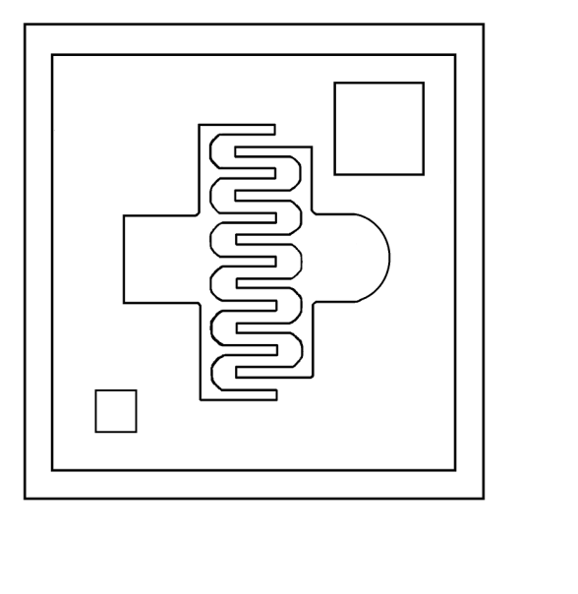
S
D
.017”
.017”

Top Material: Al
Backside Material: Au
Bond Pad Size: .004” min.
Backside Potential: Gate
Mask Ref:

APPROVED BY: DK DIE SIZE .017” X .017” DATE: 10/20/21
MFG: INTERSIL THICKNESS .008” P/N: 2N4416
DG 10.1.2

Rev B, 7/19/02

